### EXPERIMENT 3:

Write a java script code to validate user registration and login form.

### PROCEDURE:

Use simple form template for your website and add the following steps

Step1: Bootstrap Form Layouts

Step2: Wrap labels and form controls in <div class="form-group">

Step3: Form controls automatically receive some global styling with Bootstrap:All

textual <input>, <textarea>, and <select> elements with class .form-control have a width of 100%.

Step4: Add a wrapper element with .form-group, around each form control, to ensure proper margins:

Step5: You can use different validation classes to provide valuable feedback to users.

Add either .was-validated or .needs-validation to the <form> element, depending on whether you want to provide validation feedback before or after submitting the form. The input fields will have a green (valid) or red (invalid) border to indicate what's missing in the form. You can also add a .valid-feedback or .invalid-feedback message to tell the user explicitly what's missing, or needs to be done before submitting the form.

Step6: Disable form submissions if there are invalid fields

**Source code:-**

Create folder week3 inside create two html files.

1 file registration.html

2 file success.html

3 file login.html

4 file success2.html

Add two images same folder.

**Code:-Registration.html**

<!DOCTYPE html>

<html lang="en">

<head>

    <meta charset="UTF-8">

    <meta name="viewport" content="width=device-width, initial-scale=1.0">

    <title>Registration Page</title>

**//css Design part**

    <style>

        fieldset{

            width:500px;

            background-image:url(n1.jpg);

            background-repeat:no-repeat;

            background-size:cover;

        }

        table tr td{

            padding-top:6px;

            padding-bottom:6px;

        }

        body{

            color:white;

        }

    </style>

**//validation using java script code**

<script>

    function validate(){

        let fn=frm.fname.value;

        for(let x in fn){

           let ch=fn.charCodeAt(x);

            if(ch<65||ch>90 && ch<97||ch>122)

            {

                alert("Invalid firstname");

                return false;

            }

        }

        let fn1=frm.lname.value;

        for(let x in fn1){

           let ch=fn1.charCodeAt(x);

            if(ch<65||ch>90 && ch<97||ch>122)

            {

                alert("Invalid Lastname");

                return false;

            }

        }

        let phn=frm.phone.value;

        let len=phn.length;

        if(len!==10)

        {

            alert("phone no. should be exactly 10 digits");

            return false;

        }

        let reg="@";

        let mail=frm.email.value;

        if(reg.test(mail))

        {

            alert("Invalid mail");

            return false;

        }

        let p1=frm.pwd.value;

        let p2=p1.length;

        if(p2>8)

        {

          alert("Password should not exceed 8 digits");

          return false;

        }

        return true;

    }

</script>

</head>

**//creating registration form**

<body style="background-image:url(nature.jpg);background-repeat:no-repeat;background-size:cover">

    <center>

        <h2>Registration</h2>

<form name="frm" method="post" action="success.html" onSubmit="return validate()">

<fieldset>

    <table>

<tr><td>First Name:</td><td><input type="text" name="fname" value="" required/> </td></tr>

<tr><td>Last Name:</td><td><input type="text" name="lname" value="" required/> </td></tr>

<!--<label for="num">Phone No.:</label>

<input type="tel" name="Mobile" id="num" maxlength="10" placeholder="Enter user Mobile No." required />-->

<tr><td>Phone no.:</td><td><input type="number" name="phone" value="" required/> </td></tr>

<tr><td>Mail Id:</td><td><input type="email" name="mailid" value="" required/> </td></tr>

<tr><td>Gender:</td>

    <td>Male:<input type="radio" name="gender" value="male"/> </td>

    <td>Female:<input type="radio" name="gender" value="female"/> </td>

</tr>

<tr><td>DOB:</td><td><input type="date" name="dob" required/> </td></tr>

<tr><td>User Name:</td><td><input type="text" name="uname" value="" required/> </td></tr>

<tr><td>Password:</td><td><input type="password" name="pwd" value="" required/> </td></tr>

<tr><td>Age:</td><td><input type="number" name="age" value="" required/> </td></tr>

    </table>

    <input type="submit" value="Registration" name="submit"/>

**//login button if existing user**

    <a href="login.html"><input type="button" value="login" name="submit"/></a>

</fieldset>

<p>Copyright CMRIT_2024</p>

</form>

    </center>

</body>

</html>

**Code:-Success.html**

<!DOCTYPE html>

<html lang="en">

<head>

    <meta charset="UTF-8">

    <meta name="viewport" content="width=device-width, initial-scale=1.0">

    <title>Document</title>

</head>

<body>

    <h2>Registration Successfull</h2>

</body>

</html>

**Code:-login.html**

<!DOCTYPE html>

<html lang="en">

<head>

    <meta charset="UTF-8">

    <meta name="viewport" content="width=device-width, initial-scale=1.0">

    <title>Document</title>

**//css Design part**

    <style>

        fieldset{

            width:500px;

            background-image:url(nature.jpg);

            background-repeat:no-repeat;

            background-size:cover;

        }

        table tr td{

            padding-top:6px;

            padding-bottom:6px;

        }

    </style>

**//validation using java script code**

<script>

    function validate(){

        let p1=frm.pwd.value;

        let p2=p1.length;

        if(p2>8)

        {

          alert("Password should not exceed 8 digits");

          return false;

        }

        return true;

    }

</script>

</head>

**//creating login form**

<body style="background-image:url(n1.jpg);background-repeat:no-repeat;background-size:cover">

    <center>

        <h2>Login</h2>

<form name="frm" method="post" action="abc.html" onSubmit="return validate()">

<fieldset>

    <table>

<tr><td>User Name:</td><td><input type="text" name="uname" value="" required/> </td></tr>

<tr><td>Password:</td><td><input type="password" name="pwd" value="" required/> </td></tr>

</table>

    <input type="submit" value="Login" name="submit"/>

**//registration button if new user**

    <a href="Registration.html"><input type="button" value="Registration" name="submit"/></a>

</fieldset>

<p>Copyright CMRIT_2024</p>

</form>

    </center>

</body>

</html>

**Code:-Success2.html**

<!DOCTYPE html>

<html lang="en">

<head>

    <meta charset="UTF-8">

    <meta name="viewport" content="width=device-width, initial-scale=1.0">

    <title>Document</title>

</head>

<body>

    <h2>Login Successfull</h2>

</body>

</html>

**Output:**

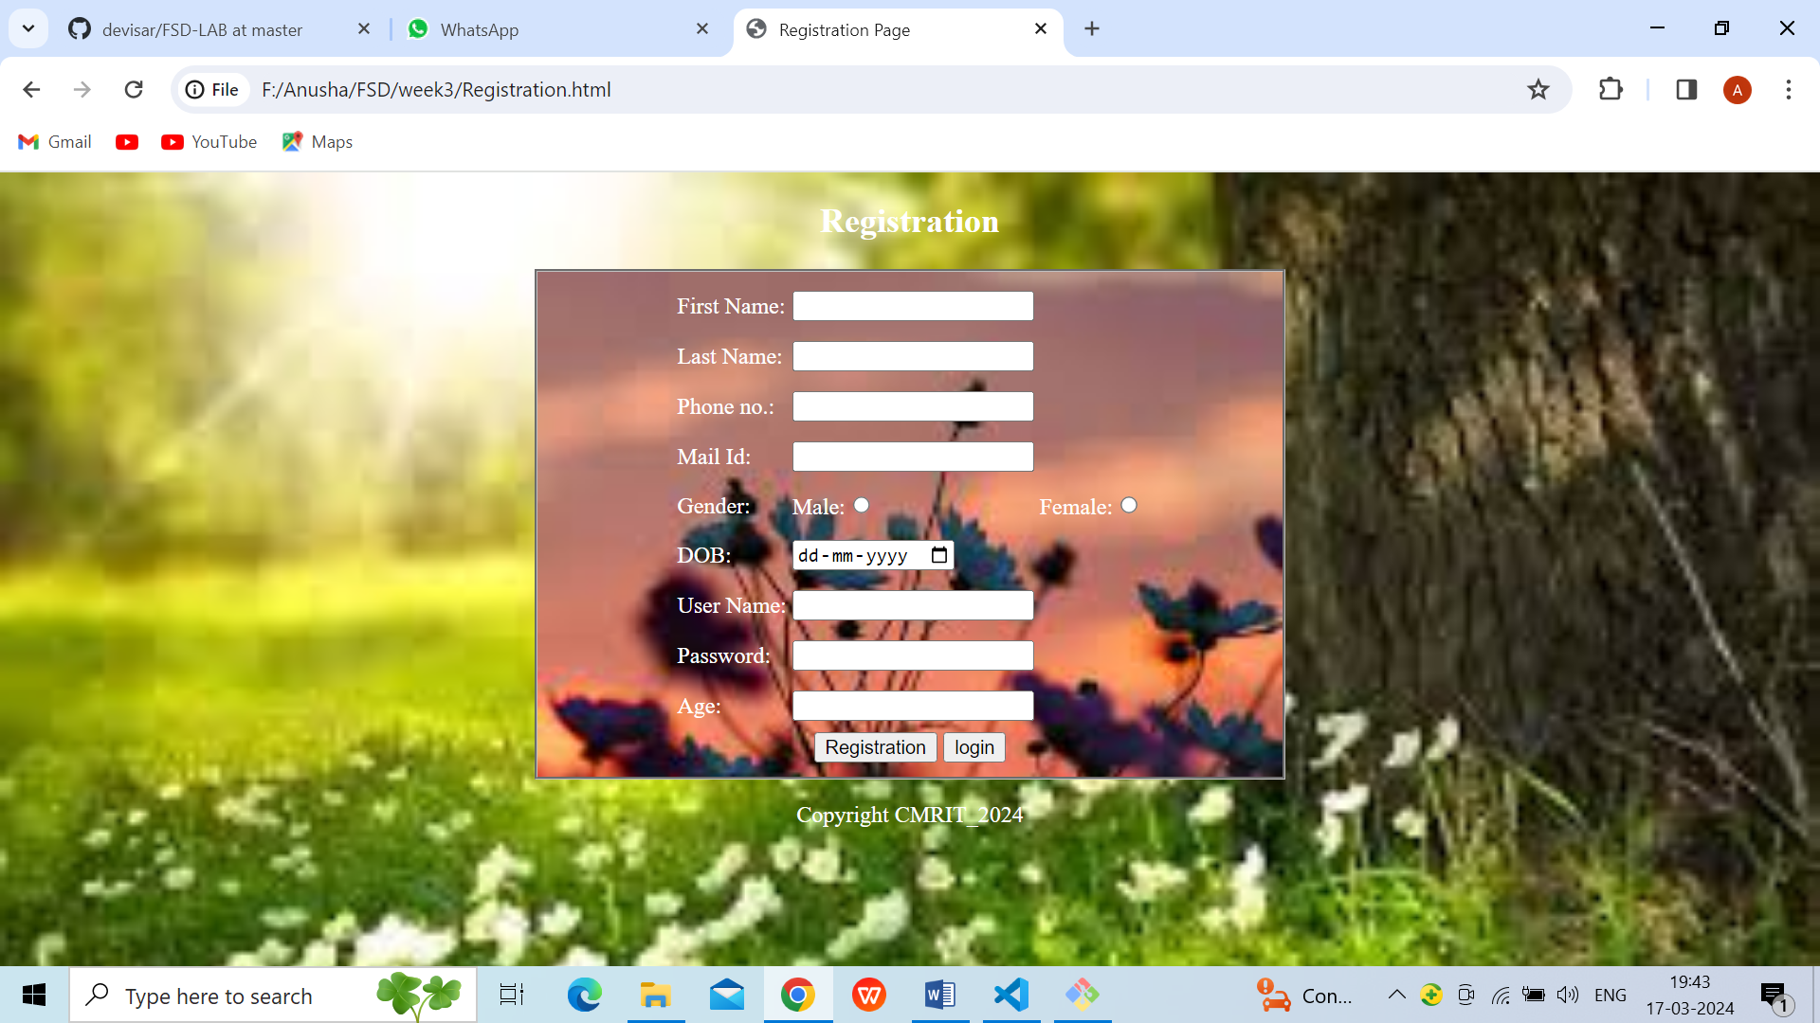

**Fig.1.Registration Page**

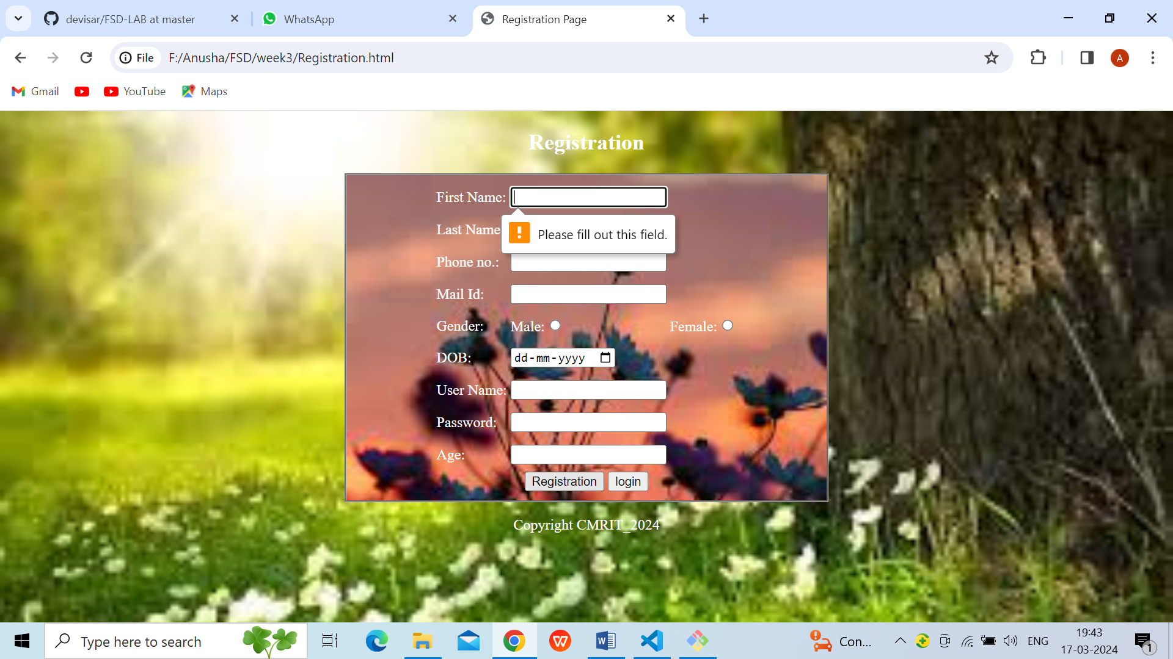

**Fig.2. Field Required Registration page**

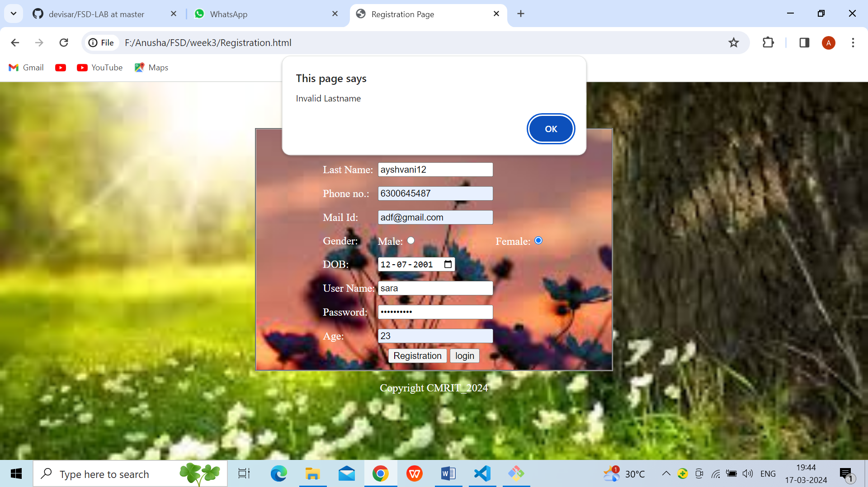

**Fig.3.Last Name Validation Registration Page**

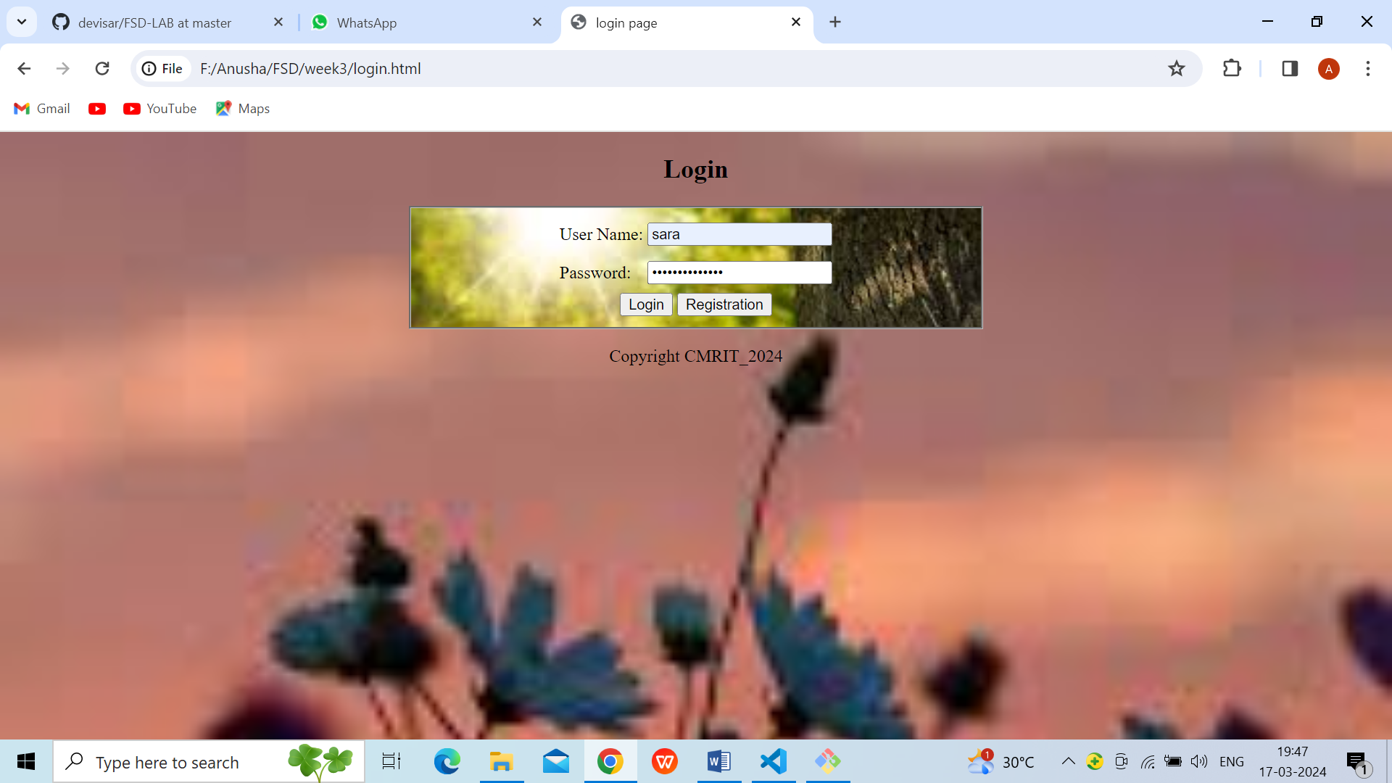

**Fig.4.Login Page**



**Fig.5.Password Validation Login Page**

**VIVA QUESTIONS:**

## Explain Key Features of Bootstrap?

**Bootstrap** is freely available for every. The main features of bootstrap is, it is very simple and easy to use, hug JavaScript plugins are available, easily design mobile friendly website.

1. Define the key components of Bootstrap?

The key components of Bootstrap are. CSS: It comes with plenty of CSS files. Scaffolding: It provides a basic structure with a Grid system, link styles, and background. Layout Components: List of layout components. JavaScript Plugins: It contains many jQuery and JavaScript plugins.

1. What are the different button styles in Bootstrap?

**Button Styles**

* .btn.
* .btn-default.
* .btn-primary.
* .btn-success.
* .btn-info.
* .btn-warning.
* .btn-danger.
* .btn-link.

## What are bootstrap alerts?

Bootstrap Alerts are used to provide an easy way to create predefined alert messages. Alert adds a style to your messages to make it more appealing to the users. There are four classes that are used within <div> element for alerts. .alert-success.

1. Why Bootstrap is used for mobile web development?

The Bootstrap has a responsive grid system that helps for building Mobile-first design. It divides the screen into 12 equal parts and arranges the CSS elements accordingly on the screen and according to the size. This feature helps in creating mobile-friendly application.